

**Water Service System** for automating processes between consumers, water providers, and well owners.

**Republic of Yemen  
Ministry of Higher Education  
and Scientific Research  
University of Since and Tech  
College of Computer and IT  
Department of Information Technology**

**الجمهورية اليمنية  
وزارة التعليم العالي والبحث العلمي  
جامعة العلوم والتكنلوجيا  
كلية الحاسوب وتقنية المعلومات  
قسم (BIT)**

Submitted by:

|  |  |
| --- | --- |
| Name | ID |
| 1.Hesham Sharaf Abdullah Mahomed | 20110101002 |
| 2. Suhaib Walid Al-Qudsi |  |

**Supervisor**

**Assoc Prof. Sadiq Tawil**

This project was submitted To FCIT in partial of fulfillment of the

Requirement for the Bachelor’s Degree of IT.

2022 – 2023

# Abstract

**Contents**

Abstract 1

Index of Tables 4

Index of Figure 5

Chapter One 6

Introduction 6

1.1 Background 7

1.2 Problem Statement 7

1.3 Objectives 8

1.4 System Definition 9

1.5 Purpose 9

1.6 Main Objective 9

1.7 User Characteristics 10

1.8 Project Scope 10

• Actual scope 10

• Operational scope 10

1.9 Limitations 10

1.10 Assumptions & Dependencies 10

Chapter Two 13

Current System 13

2.1 Introduction 14

2.2 Problems facing the consumers, water providers, and well owners 14

Chapter Three 16

System Analysis and Design 16

3.1 Overview 17

3.2 Fact and Finding tools 17

3.3 Requirements Specification 17

3.3.1 User Requirements 17

References 18

# Index of Tables

Table 1User Characteristics 10

# Index of Figure

Figure 1Incremental Model 11

Figure 2Project Plan 12

# Chapter One

# Introduction

# Background

With the development of technology, everything around us is changing. So we cannot cope with those changes if we keep using the traditional methods from the old generation. Nowadays, technology has interfered the habits in our lives, such as food ordering, the way of payments, and more.

It becomes necessary for all business to make it easy for users/ consumers as it can facilitate all the services they need in their daily life.

The consumers suffer from getting the water service from the water provider or well owner if he/she subscribes to the well. Also, the well owner cannot track the units consume unless he goes to the consumer and register the units the consumer used, then match it with the previous units reading. This operation takes time and effort and sometimes gets into mistakes. So, it is necessary to automate the whole operation to save time and effort.

# Problem Statement

The problem is that water consumers cannot deal with water provider in an efficient and easy way. They need to contact the water provider directly and looking for one and this takes time, also the water well suffer in dealing with consumers to provide them with units consumes and report, the problems are:

1. The consumer has to look for a water provider by asking other neighbors and then making phone calls and that takes time and effort.
2. In some areas the water wells provide water directly to the consumer through water delivery pipes. Hence, the consumer needs to know when the water wells are available.
3. If the consumers have direct pipes from the water wells they need to know how many units they consume during a certain period of time (need detailed report).
4. If the consumer is new in the area he/she needs to know the nearest water well to his/her location.
5. The consumer has to pay the fees hand to hand, and this traditional method takes time and effort.
6. The consumers do not know the well that the water provider deals with or the size of the vehicles that drives them.
7. To be provided with water from the water wells, the water providers need to line up for each operation and this also takes time and effort.
8. The water provider face a problem during the calculation of consumed water units between consumer or water wells.
9. The water wells owners needs to count how many units each provider/ consumer consumes during period of time.
10. The water wells owner assign a person to register the units consumes manually.

# Objectives

In order to solve the above problems the project aims to.

1. The app will provide all the water providers with the needed details about water wells, consumers and other necessary details, and the customer only needs to search for the water provider and contact him through the app.
2. The app will send notification when the water is available from the water wells.
3. The app will generate detailed reports about the units consumed, duration, and provider details.
4. The app will show the nearest water provider and water wells to the consumer location using the GPS.
5. The app will provide online payment service.
6. When the consumer choose the water provide it can see which well he deals with and the size of the vehicle.
7. When the water provider needs to be provided with water from the wells all it needs by the well employee scan the provide barcode and insert the units.
8. Each operation will be documented in the app. So, no need for traditional calculation. Both the water well owner and the consumer will get notification for each operation.
9. The app will generate a report for the provider and consumers about the units they consume and duration.
10. When the reader needs to read the units from the consumers, s/he only scan the barcode cod and insert the current units.

# System Definition

The project consists of three applications that manage water providing service and facilitate the communication process between the consumer, provider, and well. It enables the consumer to search for providers or wells and also get details reports about the unit costs, units consumed, and the water providers that the consumer deals with. The provider will also get advantages from the app as it will help in documenting the water providing operations between the consumer and wells. The well will read the units and insert them in the app directly and the consumer will get a notification about the how much water is consumed and the fees through the app with detailed reports.

# Purpose

The main purpose for applying this project is to facilitate water delivery and the communication process between the consumer, provider, and well owner. Consumers will communicate with provider/well in an easy way and less time and also get detailed reports about all operations. The provider will be able to deal with many wells and get reports about the units consumed each day. In addition, the well owner will use the application to register the units consumed more efficient and helpful way.

# Main Objective

Automate the process between the consumer, well owner, and water provider.

# User Characteristics

|  |  |  |
| --- | --- | --- |
| Users | Skills | Tasks |
| Consumer | non | * Deal with multiple provider and wells, * Get details report about the units consume from provider/ well * Do payment for water provider and wells owner. * See the nearest provider/ well. |
| Water Provider | non | * Deal with multiple consumer and wells. * Do payments to wells owner. |
| Well Owner | non | * Deal with multiple consumer and provider. * Send notification to the consumer, |
| Units Reader | Non | * Register the consumed units, |

Table 1User Characteristics

# Project Scope

## Actual scope

Yemen, Sanaa

## Operational scope

* The consumer will be able to search the nearest provider/ well, and deal with and also, do payment through the app.
* The provider will be able to manage the operations between the consumer and the well owner.
* The well owner will get detailed reports about the units consumed form the well.

# Limitations

There are some limitations that prevent from achieving the project functionality such as:

1. Users are afraid of digital systems.
2. Not knowing how to use the apps.

# Assumptions & Dependencies

In order to avoid these limitations we will try to do the following steps:

1. Demonstrate the benefits of the system to the users.
2. Offer a user guide for the system.
3. **Life Cycle Model**

The methodology used is the incremental model (Model Incremental).

• Reasons for choosing the methodology:

1 - Clarity and full understanding of the requirements for the system.

2 - The ability of the system to develop.

3- Flexibility of the methodology in keeping pace with technology, and its scalability for development.

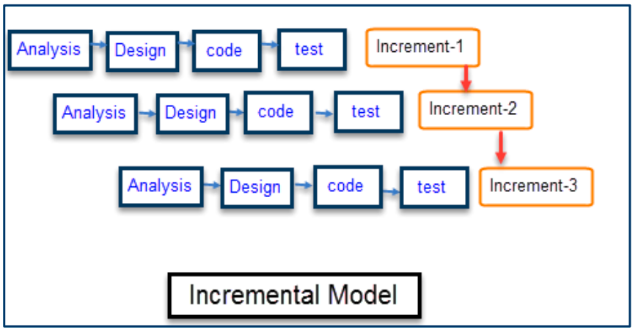

Figure 1Incremental Model

1. **Project Plan**

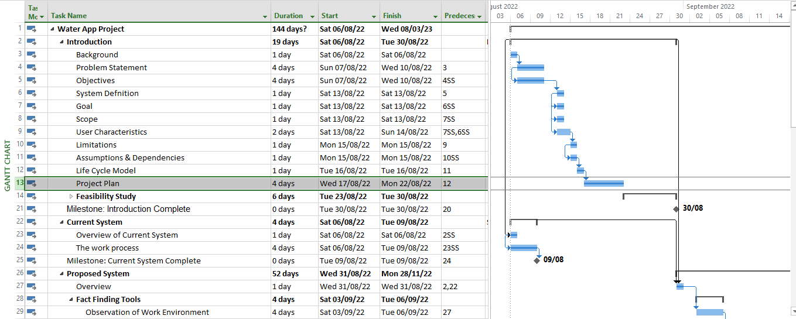 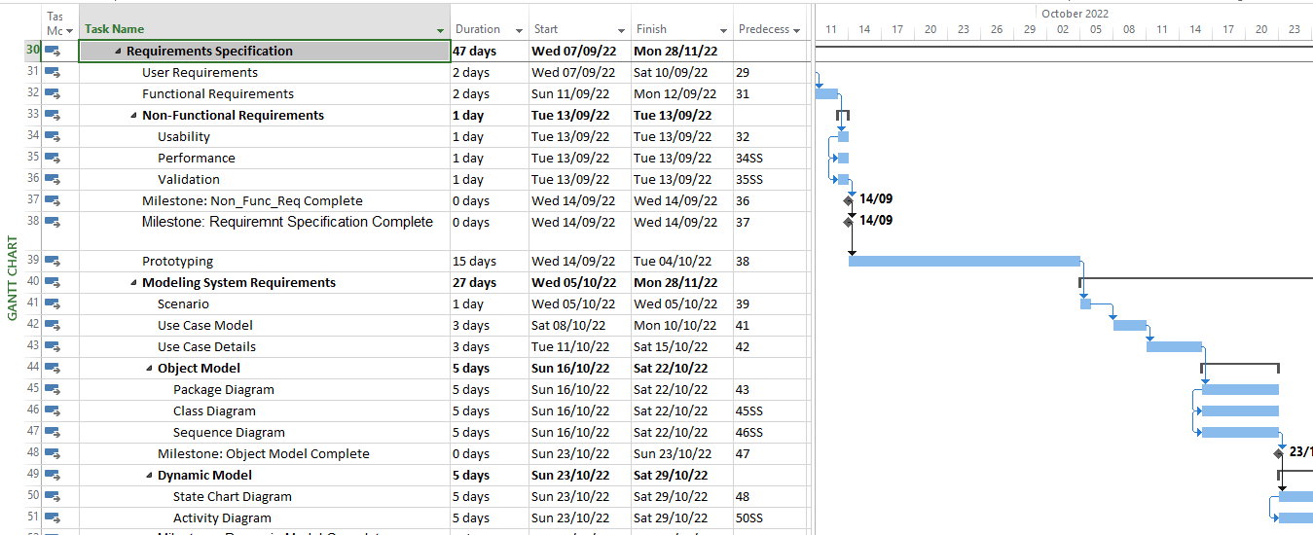 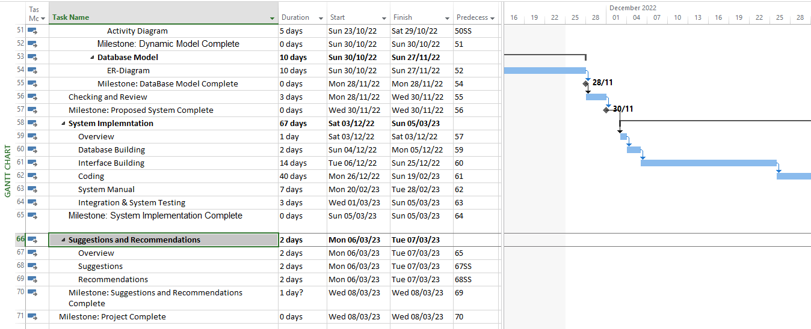

Figure 2Project Plan

# Chapter Two

# Current System

# Introduction

Given the consumer's need for water, s/he then searches for the means that will provide him with water. Water is delivered to homes through two methods: the water provider or the consumer in partnership with the owner of the nearest well. The consumer faces many problems while delivering water to him in the two previously mentioned ways.

# Problems facing the consumers, water providers, and well owners

Some of these problems that occur with the water provider are: first, the inability of the consumer to quickly access the water provider; second, the inability of the consumer to choose the right size and price according to his needs; third, the delay of the water supply for the consumer due to work pressure and lack of arranging tasks.

Some of these problems are related to the owner of a well: first, the water was cut off without warning; second, late payment due to not receiving the invoice at the right time. There are things that happen between the owner of the well and the water supplier: first, the frequent crowding of water suppliers; second, not knowing the exact number of times the provider provides.

We will divide the problems facing all parties:

1. Well owner and consumer:

The consumer registers and pays the service fee to bring water from the well to the house, then the owner of the well sets the unit price for the customer on a monthly basis, after that, the owner of the well records the readings at the end of the month and the water meter issues monthly bills to the consumer.

Problems while providing water supply service include:

1. The delay in getting the service due to lack of communication.
2. Delay in delivering invoices on time.
3. Late payment.
4. Some errors occur in the reading of the water meter and the method of calculating and issuing the bill.
5. Well owner and water provider:

The water provider fills the water from the well; then the owner of the well records the number of times the provider gets water from the well and the cost in two ways, either immediately or at the end of the day, where prices vary according to the sizes and capacities of the water providers and the well.

The problems that occur include:

1. Not adjusting the prices of filling from the well to the owner of the water provider.
2. It is not easy to record the number of filling times for the water provider on a daily basis.
3. There is no regulation of payment methods, whether cash or deferred.
4. Water supplier and consumer:

The consumer submits the request by calling the water provider, where the water provider comes to empty the water at the consumer’s house; then the consumer pays the cost to the water provider through three methods: (direct payment (cash), payment at the end of the month (duration), payment by money order)

The problems that occur include:

1. It is not easy to reach the water provider by calling.
2. It is not easy to explain the site to the water provider.
3. There is no organization and arrangement in the tasks of the owner of the water provider.
4. There are problems in the payment methods by the consumer.

# Chapter Three

# System Analysis and Design

# Overview

With any new project that to be created, we need to find and collect information to have knowledge about the project and know the steps to perform a task. In this chapter, we clarify the ways we follow to collect information. Also, clarify the users of the system and their role and tasks by UML diagrams, and the database of the system required.

# Fact and Finding tools

* **Observation**

To use this method we went to multiple well owners and water providers. We observed how processes and activities are done. According to this observation, we have obtained a lot of ideas and knowledge that were not clear from the beginning.

# Requirements Specification

## User Requirements

* Water supplier

1. The ability to subscribe to the application via a password and a username
2. The ability to identify the highest priority consumers
3. Determining who paid and who did not without resorting to paperwork
4. Locating consumers via the map

* The owner of the well

1. Issuing invoices periodically
2. The ability to read the water meter via a barcode
3. Determine the location of the consumer and the Water supplier through the map
4. The ability to send money online

* The consumer

1. Display the previous and current readings of the meter
2. Knowing the areas of well owners and knowing their quality
3. Knowing the distance that the Water supplier needs to reach.
4. The ability to send money online
5. Knowing the working hours of the well owners and the Water supplier and whether it is active or not

## Functional Requirements

* 1. Issuing and saving reports on the current and previous user readings.
  2. Determine the amount of consumption and the cost required by the consumer
  3. Determine the working hours of wells and water distributors for users
  4. The ability to send money online.
  5. Determine the areas of each of the wells, water distributors and consumers

## 3.3.3 Nonfunctional requirement

Non-functional requirement are requirements that are not directly concerned with the specific services delivered by the system. They may relate to emergent system properties such as usability, dependability (Reliability, Validation, Safety, Security, Performance). Alternatively, they may define constraints on the system implementation such as the capabilities of Input/output devices or data representation used in interface with other applications.

* + - 1. **Usability**
* The user interface must be easy and attractive to use.
* The system is expected to be efficient to use, which means it may take less time to accomplish the required functions.
* The overall system expected to be easy to use.
  + - 1. **Dependability**
         1. **Reliability**
* The application should operate as the user requires.
* Data must be stored and retrieved in a consent way.
* The rate failure in application should be small.
* The recovery from failure should be very fast.

* + - * 1. **Validation**

If the user have entered wrong inputs, the application inform the user about that by

notification massage.

**3.3.3.3 Safety**

The system should not be harmful for the environment and people that surrounding.

* + - 1. **Security**

The application has authentication method as username and password, also assess the application according to the user privilege.

* + - 1. **Performance**

The application should be high performance (speed in performing tasks) to meet all the requirements. Performing the application operations and its performance is set as the following points:

* + - * 1. **Availability**

An application's availability is the amount of time that users can use the application operations. In addition, Application can be easily accessed at any time.

* + - * 1. **Throughput**

The application should be as fast as possible in performing processes of the application.

* + - * 1. **Response Time**

We aim to make the system as fast as possible, so that it performs the largest amount of operations as (issuing the quantity tables from the concerned department and at the same time issuing the quantity tables from the shared departments) and follow up the paperwork progress from the requesting to the end of the borrowing request.

* + - 1. **Accuracy**

The application designed to perform operations with correct output. Also, when issuing or printing reports the data entered should be correct.

* + - 1. **Maintainability**

There will be a continuously maintenance for the system, also to keep up with the new technology and changing of interfaces by time go on. In addition, the application maintainable with addition requirements and with user new or change requirements

# References

* Joseph S. Valacich, Joey F. George. (2016; 2017). [Modern systems analysis and design](http://library.lol/main/0C7FD5EE4ED4F1E89E89A736AC6A39A0). Prentice Hall: Pearson.
* Ian Sommerville. (2016). Software engineering. Pearson.